U-10 7v7 Modified Rules
No coaching by either coaches or parents will be allowed from behind goals at any time!
Revised 8/10/2016

Law 1 - The Field of Play
A. Dimensions: The field of play must be rectangular. The length of the touchline must be greater than the length of the goal line. Maximum Size: 30 Yards Wide / 47 Yards Long
B. Marking: Distinctive lines not more than (5) inches wide. The field of play is divided into two halves by a halfway line. Center Circle shall be marked with a 8 yard radius. Corner Arcs will have a 1 yard radius. Goal Area 5 yards from each goal post & 6 yards into the field of play joined by parallel lines. Penalty Area 13 yards from each goal and 12 yards into the field of play joined by parallel lines.
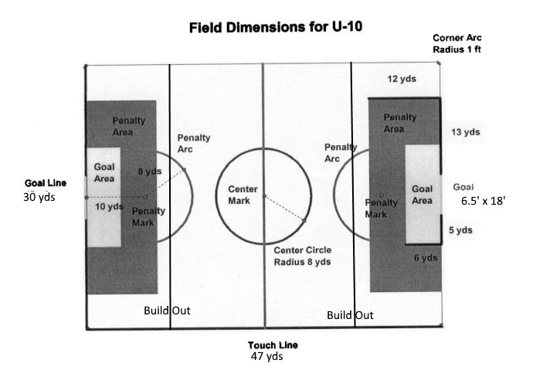
C. Goals: 6.5 feet high by 18 feet wide. Goals must be anchored at all times.

Law 2 – The Ball
Size 4

Law 3 – Number of Players
A match is played by two teams, each consisting of not more than seven (7) players on the field, one of whom is the goalkeeper.
A match may not start if either team consists of fewer than five players. The maximum team roster size is fourteen (14).
Substitutions: After approval from the referee, at any stoppage of play and unlimited.
Playing time: Each player WILL play a minimum of 50% of the total game. Exceptions only as allowed by FCYSL policy.

Law 4 – Player’s Equipment
Shinguards: Required for all practices as well as games. Must fully cover the shin from ankle to just below the knee.
Shoes: Running shoes or soft-cleated shoes appropriate for playing soccer.
All players need a matching jersey with a unique number for the games as determined by their club.
NO JEWELRY IS TO BE WORN AT ANY TIME BY ANY PLAYER. HAIR TIES OR HEADWEAR MAY NOT CONTAIN ANY HARD OR METAL OBJECTS WITHIN THEIR STRUCTURE.

Law 5 – Referee

The league will attempt to provide certified referees, but in the event that a referee is not present within 10 minutes of scheduled game time, a parent referee should be used. All referee decisions will be final. All infringements shall be briefly explained. Coaches should not referee their own games.

Law 6 – Assistant Referee
Parent Linesman should be used.

Law 7 – Duration of the Match
Conform to the FIFA with the exception of the match being divided into two (2) equal halves of twenty-five (25) minutes. There shall be a half-time interval of five (5) minutes.

Law 8 – Start and Restart of Play

A coin toss at the beginning of the game will determine which team shall kick-off. The winner of the coin toss shall choose the direction of play, & the loser of the coin toss shall kick-off. The winner of the pre-game coin toss shall kick-off at the beginning of the second half. Teams will change directions at halftime. Kick-off will be taken at the center circle. All players from the defending team must remain outside the circle until the ball has been played. The player taking the kick-off shall not play (touch) the ball again until it has been touched by another player, of either team. A kick-off is a direct kick, therefore a goal may be scored from a kick-off. A kick-off will be used to restart play after a goal has been scored. The kick-off is given to the team that was scored against. Play may be restarted with goal kicks, kick-ins, or drop balls, as appropriate. Drop balls shall be used when play is stopped for any reason other than for the calling of a foul.

Law 9 – Ball In and Out of Play
The ball is said to be “out of play” when the whole of the ball has crossed all of the goal line or touch line, either in the air of on the ground. The ball is “in play” at all other times that it is in the field of play, including when it rebounds from goalposts, crossbars, or the parent referee.

Law 10 Method of Scoring.
Scores are to be kept, and no record of standing will be maintained by the league.

Law 11- Offside.
Conform to the FIFA Laws of the Game, with the exception that the build-out line also serves as an offside line for the attacking team. A player is not in an offside position if they are on their own side of the build-out line.

Law 12 – Fouls and Misconduct

Conform to the FIFA Laws of the Game with the following exceptions: An indirect free kick is awarded to the opposing team at the center spot on the halfway line if a goalkeeper punts or drop-kicks the ball. When a player deliberately heads the ball in a game, an indirect free kick is awarded to the opposing team from the spot of the offense.

Law 13 - Free Kicks.
A goal may be scored if, after taking the kick it is touched by another player before entering the goal. Indirect free kicks are indicated by the referee holding 1 hand above their head, and holding it in the air until such time as it is kicked and then touched by another player, from either team. All opponents must be at least 8 yards from the ball.

Law 14 - Penalty Kicks.
Penalty Kicks can be awarded.

Law 15 – The Throw-In

Will be given to the opposing team of the last player that touched the ball before going out of play. The whole of the ball must have fully crossed the touch lines of either side of the field, and will be thrown in at the point where the ball left the field. The ball must be thrown, from behind the head, with both hands, coming over the head. Both of the throwers feet must be in contact with the ground, with both feet on or behind the touchline, at the moment the ball is released. All opponents must be at least 2 yards from the ball.

Law 16 – The Goal Kick

Conform to the FIFA Laws of the Game with the exception that opposing players must retreat behind the build out line until the ball is in play. The team taking the goal kick may choose to restart play before the opponents have retreated behind the build out line. The ball is in play when it is kicked directly out of the penalty area. The same procedures apply when the goalkeeper has gained possession with the hands. The opposing players must retreat behind the build out line until the ball is put into play by the goalkeeper. The goalkeeper may choose to restart play before the opponents have retreated behind the build out line. The ball is in play when it is released from the hands of the goalkeeper.

Law 17 – The Corner Kick
Conform to the FIFA Laws of the Game with the exception that the ball shall be placed in the corner of the field and the opposing players are to be at least eight (8) yards away from the ball until it is kicked.

Team/Spectator Seating
Players and coaches from both teams will sit on the same side of the field, on opposite sides of the center line. Parents and other spectators shall sit on the opposite side of the field, directly opposite of their teams and on opposite sides of the center line.

