U-7/U-8 4v4 Modified Rules
No coaching by either coaches or parents will be allowed from behind goals at any time!
Revised 8/10/2016

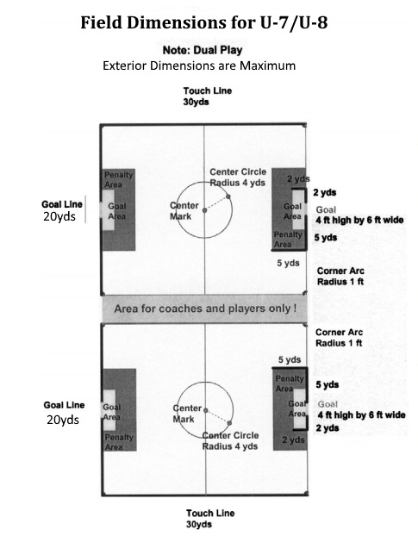
Law 1 - The Field of Play. U-7/U-8 4v4
A. Dimensions: The field of play must be rectangular. The length of the touchline must be greater than the length of the goal line. Maximum Size: 20 Yards Wide / 30 Yards Long
B. Marking: Distinctive lines not more than (5) inches wide. The field of play is divided into two halves by a halfway line. Center Circle shall be marked with a 4 yard radius. Corner Arcs will have a 1 yard radius. Goal Area 2 yards from each goal post & 2 yards into the field of play joined by parallel lines. Penalty Area 5 yards from each goal and 5 yards into the field of play joined by parallel lines.
C. Goals: 4.5 feet high by 9 feet wide. Goals must be anchored at all times.

Law 2 – The Ball
Size 3

Law 3 – Number of Players
Maximum number of player on the field at one time: 4 with no goalkeeper.
Dual Play (2 fields, simultaneous play) with 4 vs 4, no goalkeeper
Substitutions: Between quarters, at half-time, and for injuries only.
Maximum number of players on the roster shall not exceed 16 and minimum players 10.
Playing time: Each player WILL play a minimum of 50% of the total game. Exceptions only as allowed by FCYSL policy. Teams and games may be CO-ED.

Law 4 – Player’s Equipment
Shinguards: Required for all practices as well as games. Must fully cover the shin from ankle to just below the knee.
Shoes: Running shoes or soft-cleated shoes appropriate for playing soccer.
All players need a matching jersey for the games as determined by their club.
NO JEWELRY IS TO BE WORN AT ANY TIME BY ANY PLAYER. HAIR TIES OR HEADWEAR MAY NOT CONTAIN ANY HARD OR METAL OBJECTS WITHIN THEIR STRUCTURE.

Law 5 – Referee
Each team shall provide 1 parent referee for dual play. Coaches may not referee their own games. All referee decisions are final. All infringements are briefly explained out loud.

Law 6 – Assistant Referee
None.

Law 7 – Duration of the Match
The match shall be divided into four (4) periods of ten (10) minutes. There shall be a two (2) minute break between each period.

Law 8 – Start and Restart of Play
A coin toss at the beginning of the game will determine which team shall kick-off. The winner of the coin toss shall choose the direction of play, the loser of the coin toss shall kick-off.
The winner of the pre-game coin toss shall kick-off at the beginning of the second half (3rd quarter). Restart of play at the beginning of the 2nd and 4th quarters will be at the point where the ball was stopped at the end of the 1st and 3rd quarters (i.e. throw-in, corner kick etc.) Teams will change directions at halftime.
Kick-off will be taken at the center circle. All players from the defending team must remain outside the circle until the ball has been played. The player taking the kick-off shall not play the ball again until it has been touched by another player of either team.
A Kick-off will be used to restart play after a goal has been scored. The kick-off is given to the team that was scored against. Play may be restarted with goal kicks, kick-ins, or drop balls as appropriate. Drop balls shall be used to restart play when play is stopped for any reason other than a foul. The drop ball will be taken at the point where the ball stopped.

Law 9 – Ball In and Out of Play
The ball is said to be “out of play” when the whole of the ball has crossed all of the goal line or touch line, either in the air of on the ground. The ball is “in play” at all other times that it is in the field of play, including when it rebounds from goalposts, crossbars, or the parent referee.

Law 10 Method of Scoring.
No scores are to be kept, and no record of standing will be maintained by the league.

Law 11- Offside.
No offside shall be called at this age.

Law 12 – Fouls and Misconduct
Conform to the FIFA Laws of the Game with the exception that all fouls shall result in an indirect free kick.
When a player deliberately heads the ball in a game, a direct free kick should be awarded to the opposing team at the nearest direct point on the halfway line or touchline.
The game official must explain ALL infringements to the offending player. No cards shown for misconduct

Law 13 - Free Kicks.
All kicks shall be indirect in nature. A goal may be scored if, after taking the kick it is touched by another player before entering the goal. Indirect free kicks are indicated by the parent referee holding 1 hand above their head, and holding it in the air until such time as it is kicked and then touched by another player, from either team. All opponents must be at least 4 yards from the ball.

Law 14 - Penalty Kicks.
None will be taken at this age.

Law 15 – The Throw-In
Throw-Ins shall be taken at the spot the ball left the field of play on the touchline.

Law 16 – The Goal Kick
The ball shall be placed on the goal line one (1) yard to the outside of either goal post. Opposing players step four yards away from the ball and once it is kicked then game on.
Optional: Dribble-In.

Law 17 – The Corner Kick
Conform to the FIFA Laws of the Game with the exception that the ball shall be placed in the corner of the field and the opposing players are to be at least four (4) yards away from the ball until it is kicked.
Optional: Dribble-In.

Team/Spectator Seating
Players and coaches from both teams will sit on the same side of the field, on opposite sides of the center line. Parents and other spectators shall sit on the opposite side of the field, directly opposite of their teams and on opposite sides of the center line.

